Navigating Virtual Lab Environment

Signing into the Virtual Machine

1. In the instructions area, click on Resources. A computer screen capture

   Description automatically generated with low confidence

2

1

1. Then Click on the Ctrl + Alt + Delete button.
2. Click in the Password box and type in Pa$$w0rd. 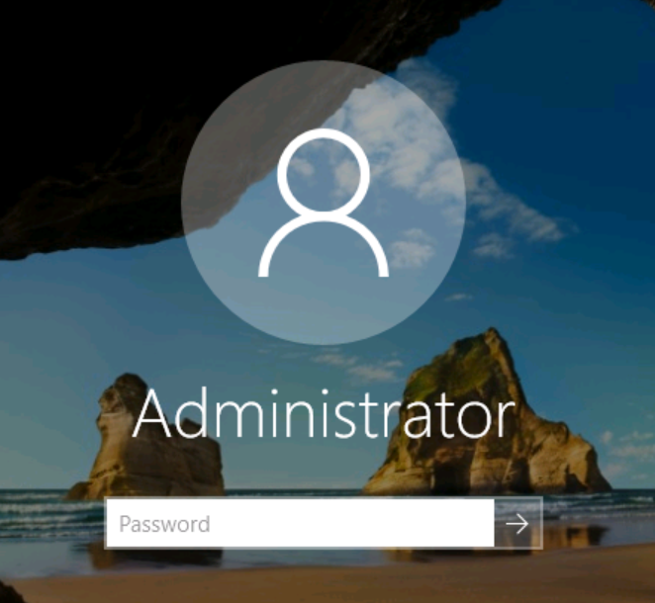
3. You could also click the Green T from the resource box. Graphical user interface

   Description automatically generated
4. To end the lab, click on the three-line menu option in the top right.
   * Save will close your lab and save any of your changes.
   * End will close the lab but not save any of your changes.
   * Split Window will allow you to move your instructions to a different monitor. Graphical user interface, text, application

     Description automatically generated
5. You can also use the lightning bolt in the top right corner to paste code from outside your virtual machine into your lab environment.

